hics

German bishop says Church must examine episcopal power

Bishop of Mainz admits sexual abuse crisis — the Church’s ‘dark side’ — has tested his faith
Christa Pongratz-Lippitt, Vienna
January 7, 2019
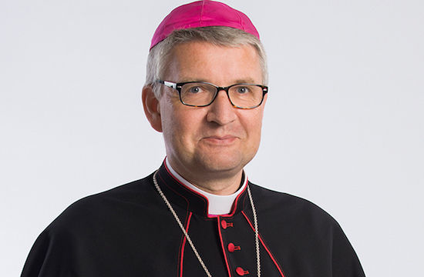
Bishop Peter Kohlgraf of Mainz. (Photo: Wikimedia Commons)
One of Germany’s youngest and more recently appointed bishops has called for a thorough examination of how Church leaders exercise their authority, saying too often it does not conform with the model St. Paul demanded of early Christian leaders.
“We urgently need to have a new look at the question of episcopal power and responsibility,” said Bishop Peter Kohlgraf of Mainz in an article that appeared on Dec. 31 in the German daily Kölner Stadt Anzeiger.
“And we must, on no account, allow the importance of this question to be played down, since it already preoccupied early Christian communities.”
The 51-year-old Kohlgraf, who succeeded the late Cardinal Karl Lehmann as bishop of Mainz in August 2017, said power is a considerable temptation for bishops. He said a good illustration of this is whether bishops respect people’s independent decisions of conscience or whether they claim the bishops alone have the sovereignty of interpretation.
Bishop Kohlgraf also admitted that the issue of sexual violence in the Church had put his faith to the test in recent months.
“I have never experienced the human and dark side of the Church so closely as in the 16 months since I became a bishop,” he said.
“A few days ago, I came across the following reflection by Cardinal Christoph Schönborn: ‘Perhaps we are too much Church and too little Christ!’
“I have given his words a great deal of thought ever since. Christ and His Church have not seldom been equated. I can still hear the following words in a sermon when I was young: ‘The Church is Christ who lives on’.”

Christ's love of humankind
But he said if the Church is identical with Christ, then it becomes unassailable, its traditions unshakeable and its ministers — “as they represent Christ Himself” — discharged from all liability.
“I feel quite clearly that we can no longer declare that the Church is Christ quite so simply. Christ is not our property. He is not at our disposal. He came into our world of His own free will, out of love. He does not cling to His power but took ‘the form of a slave, becoming as human beings are’,” Bishop Kohlgraf said, quoting St. Paul.
He pointed to the second chapter of the Letter to the Philippians (2:1-4), saying the Christian community is urged to imitate Christ through the way its members live together and behave toward one other. The community can only radiate Christ’s love of humankind if its members get on well and live harmoniously together. The community and the Church must work for and earn credibility, and that, of course, applies first and foremost to those in the Church who bear responsibility.
Bishop Kohlgraf said St. Paul warns quite clearly against careerism and vanity, making it quite clear that what is called for are the basic Christian attitudes of mercy, compassion, unanimity, empathy and sensitivity for the needs of others. Arrogance, careerism and quarrelsomeness are taboo, he noted.
The bishop lamented that, unfortunately, many Christians — including many bishops — have not lived up to St. Paul’s expectations.
He admitted to feeling particularly powerless and helpless at times since being named bishop.
But he said he remains convinced that the Gospel message wants the salvation of humankind and he hopes that Jesus Christ will make new departures possible “if we become and remain more like Him.”
* Christa Pongratz-Lippitt writes from Vienna where she has spent many years as a reporter and commentator on Church affairs in the German-speaking world

